P234.2

#include<iostream>

using namespace std;

class student

{ public:

void input();

void output();

private:

char name[20];

unsigned int id;

double score;

};

void student::input()

{ cout<<"name?";

cin>>name;

cout<<"id?";

cin>>id;

cout<<"score?";

cin>>score;

}

void student::output()

{ cout<<"name:"<<name<<"\tid"<<id<<"\tscore:"<<score<<endl;

}

int main()

{ student s;

s.input();

s.output();

}

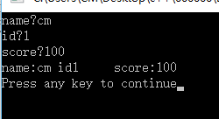

#include<iostream>

using namespace std;

class Book

{ public:

void display();

void borrow();

void restore();

char bookname[7];

double price;

int number;

};

void Book::display(){

cout<<"bookname:"<<bookname<<" price:"<<price<<" number"<<number<<endl;

}

void Book::borrow(){

number-=1;

cout<<"number:"<<number<<endl;

}

void Book::restore(){

number+=1;

cout<<"number:"<<number<<endl;

}

int main(){

int j,i;

cout<<"How many books you want to select?";

cin>>j;

Book book[10];

for(i=0;i<j;i++){

cout<<"input the"<<i+1<<" book's name";

cin>>book[i].bookname;

cout<<endl<<"input the"<<i+1<<" book's price";

cin>>book[i].price;

}

book[0].number=1;

book[0].display();

book[0].borrow();

book[0].restore();

}

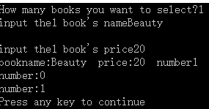

#include<iostream>

using namespace std;

class student

{

double score;

public:

static double total;

static int count;

void scoretotalcount(double s=0);

static double sum();

static double average();

};

void student::scoretotalcount(double s){

score=s;

total+=s;

count+=1;

}

double student::sum(){return total;}

double student::average(){return total/count;}

double student::total=0;

int student::count=0;

int main(){

int j,i;//j是输入人数

double sco[100];

cout<<"人数(不得超过100)";

cin>>j;

if(j<=0||j>100)cout<<"输入错误";

else{

cout<<"输入成绩"<<endl;

student stu[100];

for(i=0;i<j;i++){

cin>>sco[i];

stu[i].scoretotalcount(sco[i]);

}

cout<<"总分是"<<student::sum();

cout<<endl<<"平均分是:"<<student::average()<<endl;

}

}

